Creating the Directory Structure

Create the following directory structure; let us assume <Your Repository> is the place where all the Test Tables are organized.
<Your Repository>\Datapoolx
<Your Repository>\Datapoolx\Cycle
<Your Repository>\Datapoolx\Sutie
<Your Repository>\Datapoolx\Step
<Your Repository>\Datapoolx\Logs

For Example:
<Your Repository> ➔ C:\Test
Directory Structure
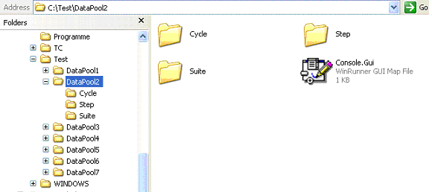

How to Start the Demo?
After successful installation of WRAFS (Refer Installation Guide), perform the following steps to run the demo.
- Extract XXXXXXXXXXX.Zip to C:\Test\DataPool1\
- Start WinRunner
- Open the “StartCycleTest” script in the WRAFS folder.
- Search for the variable “PROJECTDIR”.
- Assign PROJECTDIR the path of DataPool directory which has the Test Tables
public PROJECTDIR = "C:\\Test\\DataPoo11\\";

Now you are ready to see the Demo. Run StartCycleTest script and relax back to see the demo.

